Worksheet to Create your Interactive Custom Form

LETS TALK ABOUT YOU:
Please tell us your username

What is the Site Name and ID# from URL New Site 2015 Site # 20322

What Workspace Category (on the left navigation bar) is this form for?

Do you want the form to be the first thing you see on the page? Yes or No

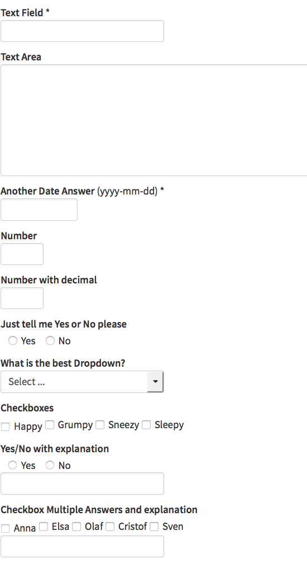
HERE’S HOW TO GET WHAT YOU WANT:
For each question list if required, question name,
answer type & answers (if applicable)

Possible answer types:
- Text Field (small)
- Text Area (large)
- Date (with popup calendar)
- Number
- Number with Decimal
- Yes/no
- Dropdown (one answer)
- Check box (multiple answers)
- Yes/no with explanation
- Dropdown with explanation
- Check box with explanation.

Example Question
Required? Yes
Question: Who’s your favorite Friend?
Answer Type: G. Dropdown
Answers (If applicable): Monica, Rachel,
Joey, Ross, Chandler, Phoebe

NOW ITS YOUR TURN TO CREATE YOUR QUESTIONS!

Question 1
Required? Yes No
Question:
Answer Type:
Answers (If applicable):

Question 2
Required? Yes No
Question:
Answer Type:
Answers (If applicable):

Question 3
Required? Yes No
Question:
Answer Type:
Answers (If applicable):

Question 4
Required? Yes No
Question:
Answer Type:
Answers (If applicable):

Question 5
Required? Yes No
Question:
Answer Type:
Answers (If applicable):

Question 6
Required? Yes No
Question:
Answer Type:
Answers (If applicable):

